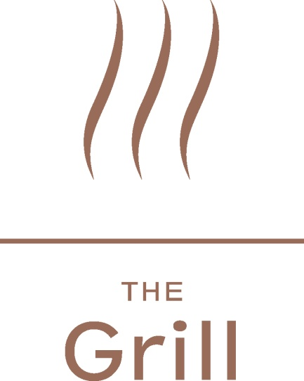

Lunch Specials
Rump
6 oz char grilled rump steak cooked to your liking
served with chips, onion rings, mushrooms and tomato - £13.80

Pork & Leek Sausage
Char grilled pork and leek sausages served with creamed potatoes
and onion gravy - £9.95
The Royal Yacht Mixed Grill
Rump of steak, pork sausage and lamb skewer,
served with chips, onion rings, mushrooms and tomato - £15.00
Omelette
3 egg omelette with fillings of your choice, mushrooms, tomato, cheese or ham
served with chips and salad - £7.25
Steak and Mushroom Pie
Steak and mushroom pie with a crisp puff pastry lid,
served with buttered mixed vegetables- £10.50

Steak sandwich
Minute steak with caramelised onions, mustard butter served in warm crusty bread with chips and salad - £7.00

Served from 11am until 3pm, Monday to Friday

The Grill Menu

The Royal Yacht Burger
8oz burger served in a sesame bun with sweet cured bacon, cheddar cheese, tomato, gem lettuce, Portobello mushroom and avocado mayonnaise, served with chips - £13.25 (10p is donated to the NSPCC Jersey when you order this main)
T-Bone
16oz T-Bone steak cooked to your liking and served with grilled vine ripened tomatoes, mushrooms, baked onion and chips - £21.50
Fillet
8oz prime fillet steak cooked to your liking and served with grilled vine ripened tomatoes, mushrooms, baked onion and chips - £23.50
Sirloin
12oz prime sirloin steak cooked to your liking and served with grilled vine ripened tomatoes, mushrooms, baked onion and chips - £21.50
Rump
12oz rump steak cooked to your liking and served with grilled vine ripened tomatoes, mushrooms, baked onion and chips - £17.25
Grilled Lamb Cutlets
Three cutlets of new season lamb cooked to your liking and served with grilled vine ripened tomatoes, mushrooms, baked onion and chips - £19.25
The Royal Yacht Mixed Grill
Rump steak, sausage, gammon steak and lamb brochette served with grilled vine ripened tomatoes, mushrooms, baked onion and chips - £19.00
The Royal Yacht “Surf & Turf”
4oz rump steak, sweet cured back bacon, lamb skewer, Grilled Tiger prawns, served with grilled vine ripened tomatoes, mushrooms and chips - £21.50
Jersey Scallops
Pan seared Jersey scallops with mash - £18.50
Optional Extras
Horseradish crème fraiche
Béarnaise
Garlic butter
Pepper corn sauce
Diane sauce
4 Grilled Tiger prawns - £3.25
Side Orders - £4.00 per portion
Chips
Buttered new potatoes
Creamed potatoes
Buttered vegetables selection
Tossed mixed salad
Onion rings

Salads & Snacks
The Royal Yacht Caesar Salad
Chicken Caesar salad with shaved parmesan and bocherone anchovies, finished with
rustic croutons - £10.50

The Royal Yacht King Prawn Caesar Salad
A classic Caesar salad served with Grilled Tiger prawns - £12.25

Mussels
Pot of mussels with white wine and garlic, cooked
in cream sauce - £7.50 starter / £11.75 main

Steak sandwich
Minute steak with caramelised onions, mustard butter served in warm crusty bread
with chips and salad - £7.00 (Available until 6pm)

Desserts
Cheesecake
Bailey’s cheesecake with butterscotch sauce and pistachio ice cream
£7.75

Chocolate Fondant
Chocolate fondant with vanilla ice cream and a mixed berry coulis
£8.50

Selection of Ices
A choice of homemade ice-creams and sorbets £6.25

Cheese
Selection of local, British and Continental cheeses served with crackers - £8.25

Coffees
Espresso - £1.80
Double espresso - £2.50
Cappuccino - £2.80
Decaffeinated coffee - £2.20
Ristretto - £1.80
Caffe latte - £2.80
Liquor coffee - £4.85
Syrups
Chai
Caramel
Vanilla
Cinnamon
Hazelnut
All syrups - £0.75
A selection of teas are also available - £2.65 per pot

